File permissions in Linux

Project description
I am a security professional at a large organization working with their research team. My task was to ensure users on this team were authorized with the appropriate permissions. This was accomplished through examining existing permissions on the file system through Linux, and modifying any permissions to authorize the appropriate users and remove any unauthorized access, according to the principle of least privilege. I have also modified permissions in directories as well, to ensure that only the appropriate user type had read, write, or execute permissions that were aligned to the company’s needs for user types.

Check file and directory details
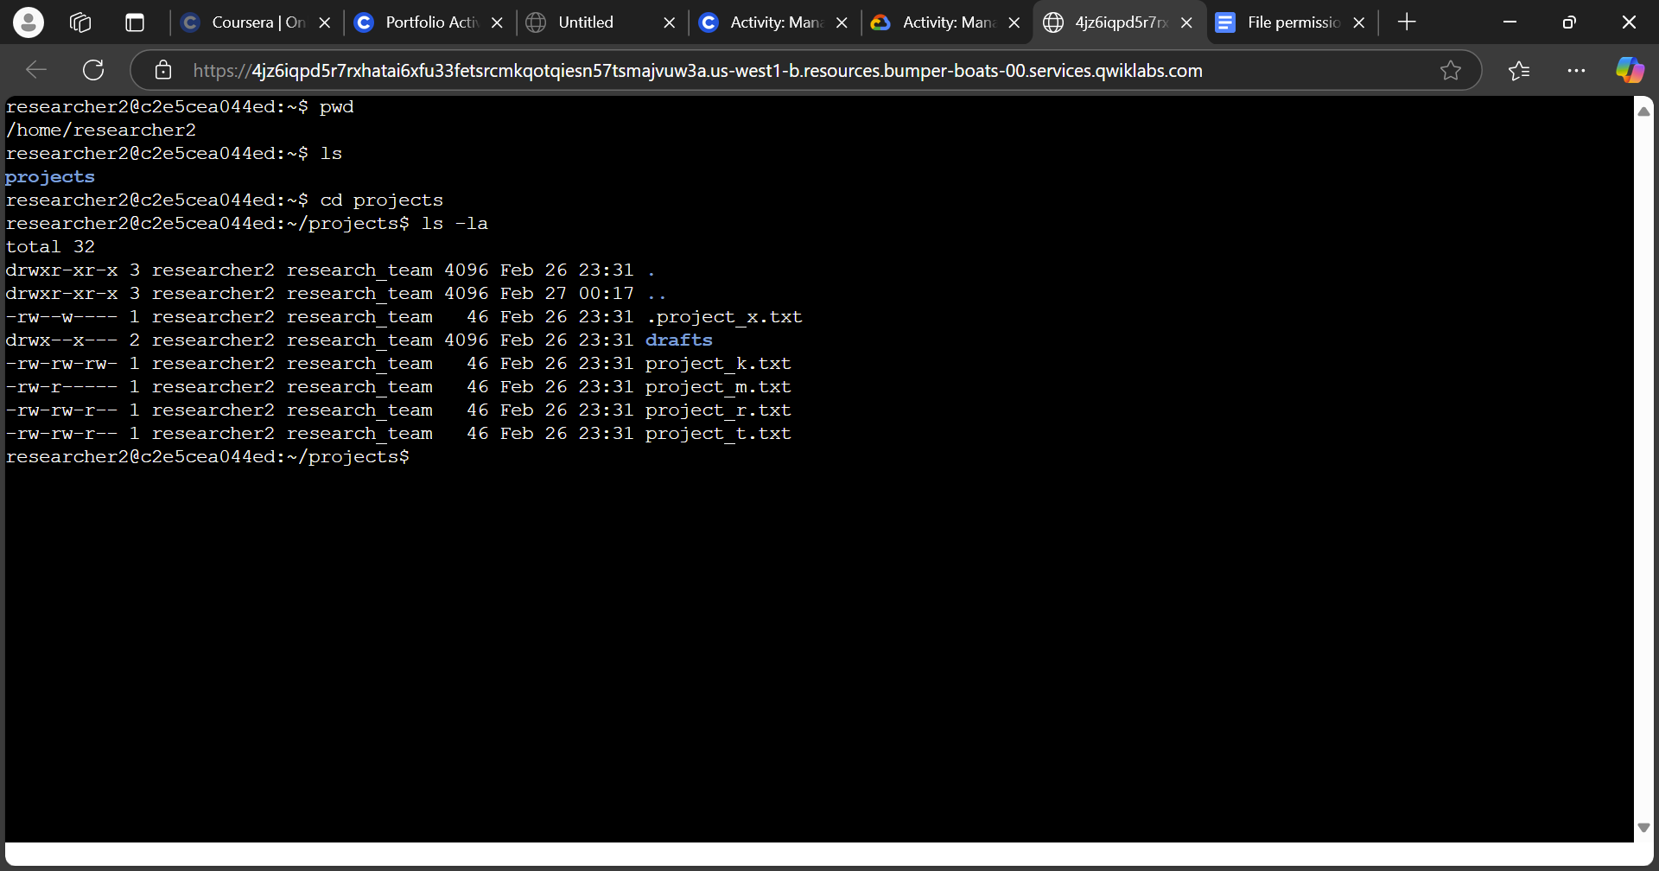
To describe the steps above in the command-line interface (CLI), first I checked which directory I was currently under, by using the pwd command. It then gave me an output of the directory I was in, which was /home/researcher2. I needed to find the projects directory, so I used ls to list out the directory and files under researcher2. Then found the projects directory in blue, and used cd projects to switch into the projects directory. I then knew that I was in the directory, since the command outputted ~/projects$, indicating that I was under the projects directory. I then checked all of the directories and files under the “projects” directory with ls -la, which showed all of the directories and files, including hidden files that had a . prefix before the file name.

Describe the permissions string
As an example, I will use the project_k.txt file to describe the permission strings and what it indicates. Using the screenshot above, on the left hand side, there is a string of ten characters that begins with -rw-rw-rw-. The first hyphen indicates whether this is a file or a directory, which in this case, it is a file. The next sequence of rw-, indicates permissions for the user, which is “researcher2” in this case. The r means that the user has permissions to read the contents in the file, the w means that the user can modify the file, or create new files in a directory, and the - indicates the user does not have permissions for an option in this specific file. In this case, there would be an x, meaning that the user could execute a file, if it’s an executable file. After the first rw-, the next rw- is for permission options for a specified group of users. This could be several users that also have permissions to a file or directory, which in this case, has the same permissions as the “researcher2” user. Finally, the last rw- sequence is for permission options of other users in the system. We can see that other users also have the same permissions to this file as the user and groups.

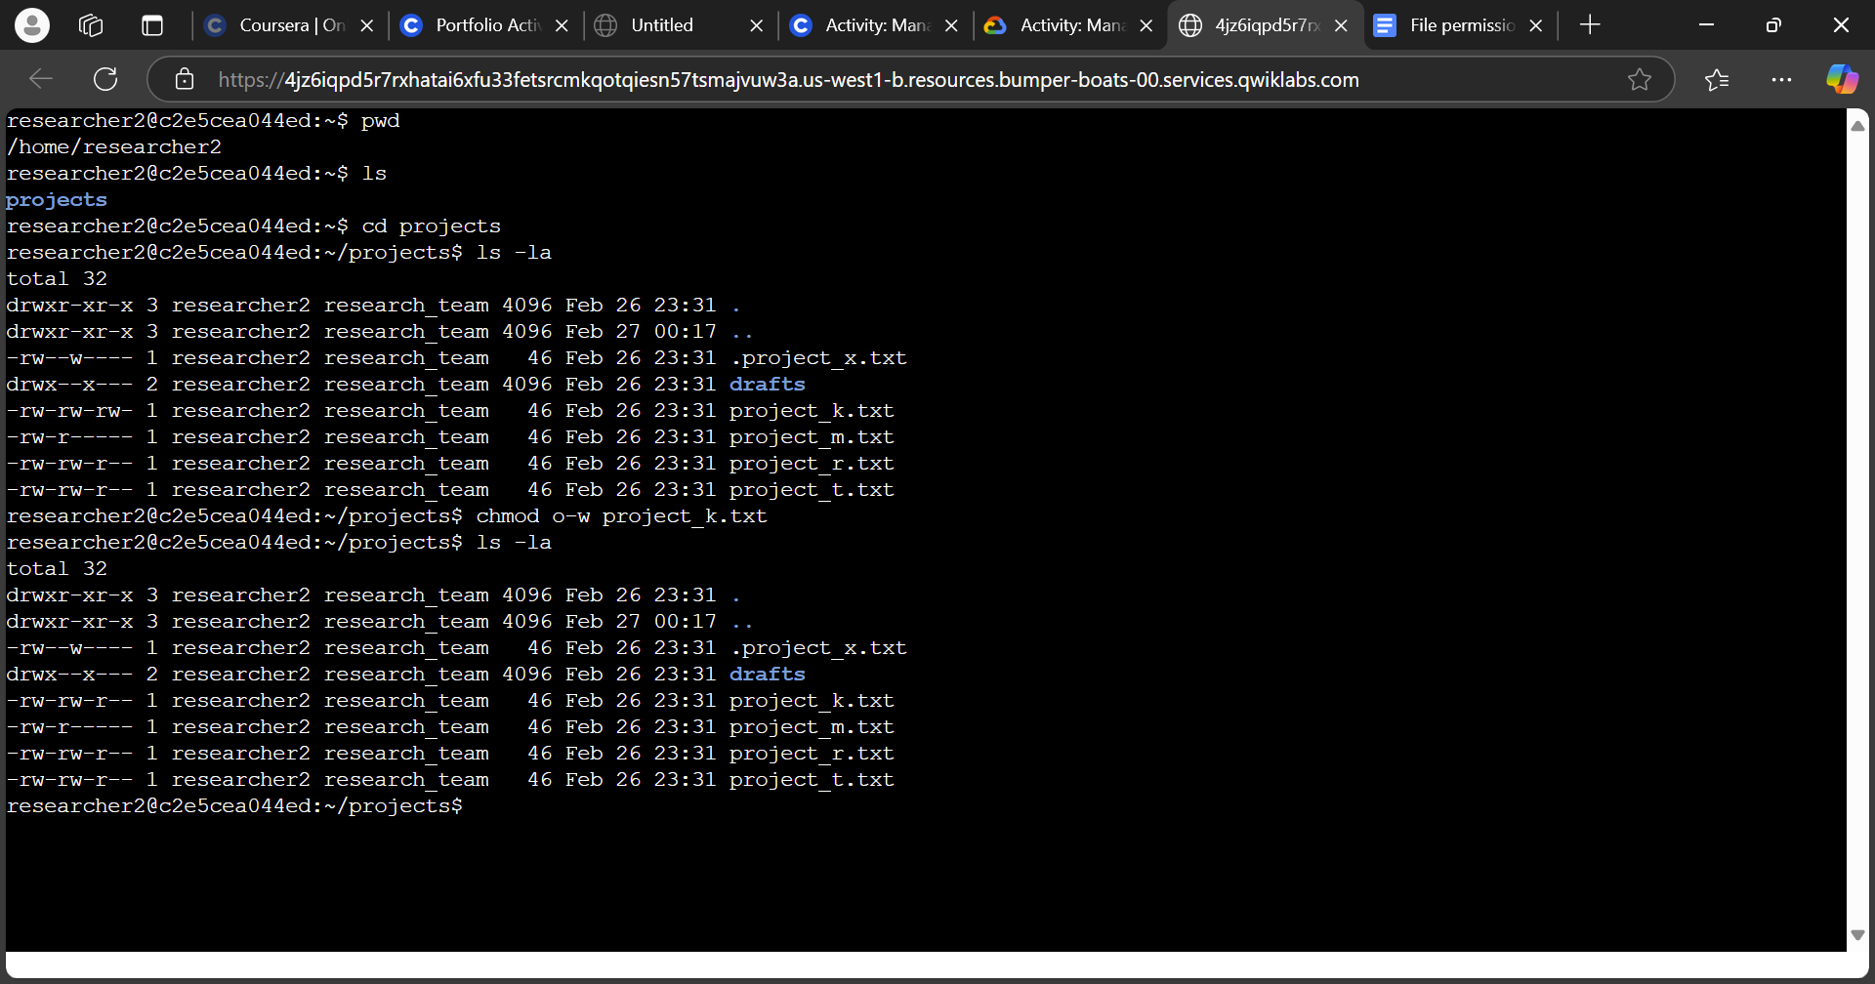
Change file permissions
In this scenario, the organization does not allow others to have “write” access to any of the files in the database. As a security professional, I had to modify the file permissions to reflect what the organization wanted: to remove “write” permissions for the other user type. To accomplish this, I first looked at each of the files and their permissions, and looked for w in the last sequence of strings. There was the “project_k.txt” that had written permissions for other, so I used the command chmod o-w project_k.txt. The chmod or “change mode” command, changes permissions on files and directories. Then the o-w argument indicates that others will have “write” permissions removed, indicated by the minus sign. The last argument indicates the target file, which was project_k.txt. To confirm the change, I used the command ls -la and confirmed that the “write” permission option for the “project_k.txt” file was removed for other users.

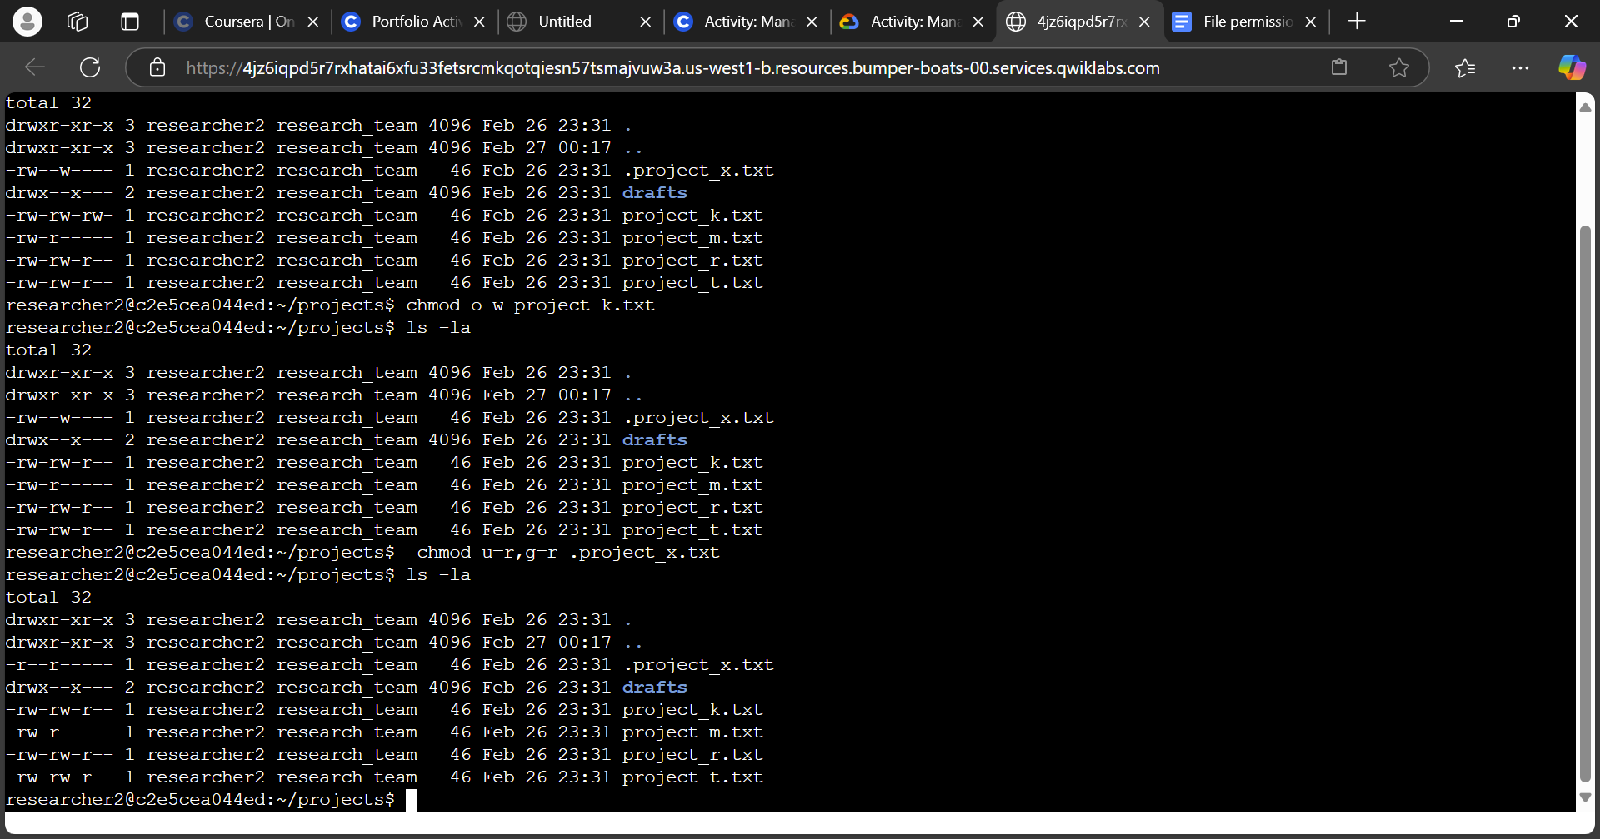
Change file permissions on a hidden file
The research team had archived .project_x.txt, which is why it’s a hidden file. The organization requested that the file should not have write permissions for anyone, but the user and group should be able to read the file. Since I used the ls -la command to list all of the files and directories, including hidden files, I was able to spot the .project_x.txt file, and was able to see that there was still “write” permissions for the user and group, and the group did not have “read” permissions. To change that accordingly, I used the command . I used the same chmod command to change permissions, but this time, I set the first argument to u=r,g=r, which indicates that the user should be assigned specifically read permissions for the hidden file, and the group should also be assigned read permissions for the hidden file. The second argument was for the hidden file, and it is indicated by the period (.) that comes before the project file name. I then used the ls -la command again to confirm that only read permissions were available to both the user and group.

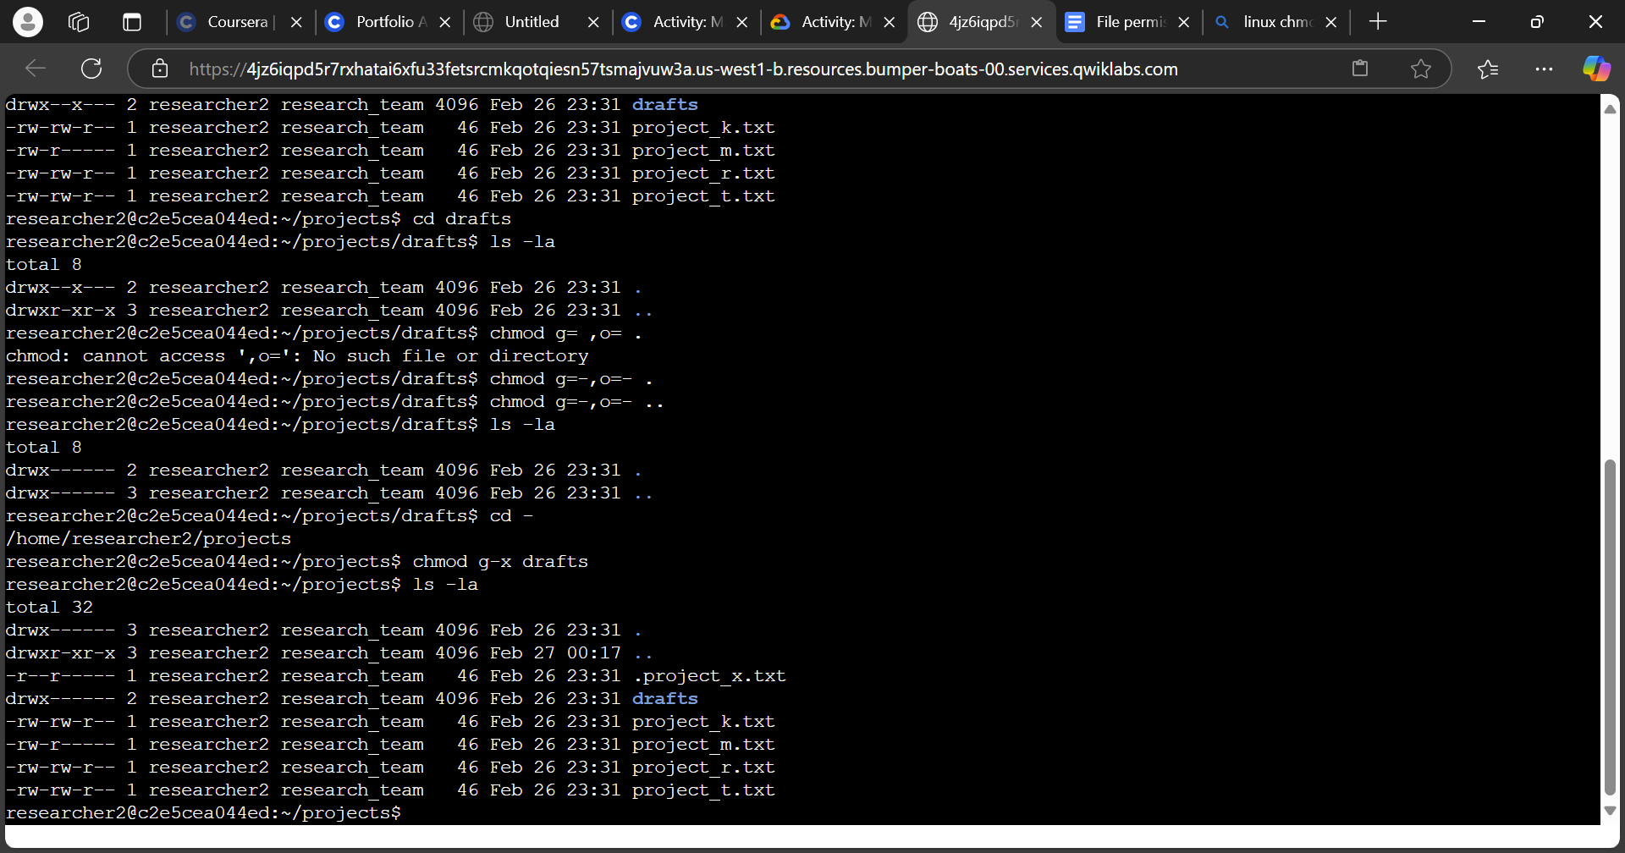
Change directory permissions
In addition to file permissions, the organization mentioned that the files and directories in the “projects” directory belong to the “researcher2” user. Only researcher2 should be allowed to access the drafts directory and its contents. I looked at the “drafts” directory and noticed that the group had execute permissions on the directory, which needed to be removed. To facilitate that change, I used the command chmod g-x drafts to remove execute permissions from other, and then used the ls -la command to confirm the changes were made to the permissions for the drafts directory.

Summary
Using Linux and its CLI, I had checked the directory and files inside in order to see its permissions with the ls -la command, including hidden files. I then modified permissions with the chmod command for files that the organization only wanted certain user types to have read and write permissions, and removed permissions from others. I then changed permissions within a hidden file, and used arguments to set specific permissions for users. Finally, I modified the permissions of a subdirectory within a directory for only the primary user to have access to.

